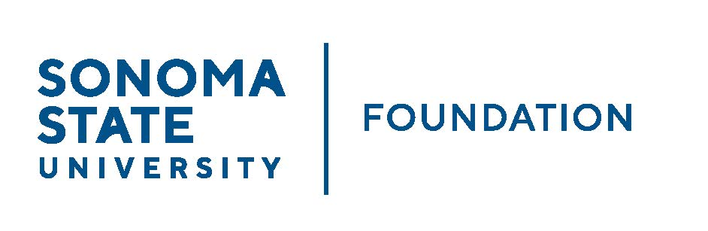

Executive Committee Session of the Board of Directors
Thursday November 21, 2024
3:00-4:00 pm
Hybrid Meeting (Salazar 2043B or Zoom)
(for dial-in instructions please email foundation@sonoma.edu)

A G E N D A

- Call to Order and Approval of September 12, 2024 Minutes

- Review of December 6, 2024 SSU Foundation Board Meeting Agenda

- Future Special Presentation Topics Schedule

- Governance Items
  - Governance committee updates - met 11/7/24

- Open Items

