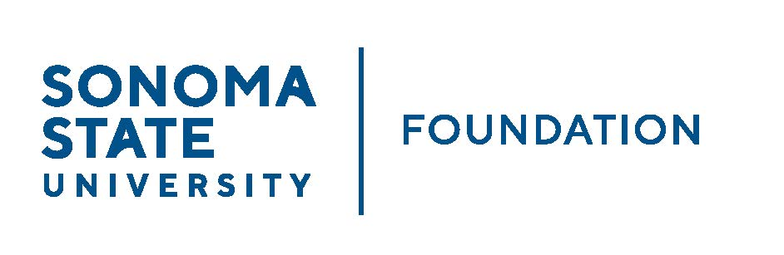

INVESTMENT COMMITTEE MINUTES

SSU Foundation Investment Committee
Wednesday May 1, 2024
3:00 - 5:00 p.m.
Location: Salazar 2043B or Zoom

Members Present: Brent Thomas (Chair) (Z), Ian Hannah, Mario A. Perez, Amanda Visser (Z), Monir Ahmed, Tom Gillespie (Z),
Mike Sullivan (Z), Doug Jordan, Ali Pourghadir (Z)

Committee Staff Present: Alicia Hodenfield, Kristin Hillman (Z)

Guests Present: Todd Au, Tony Parmisano, Drew Aviles (Z) – Graystone Consulting;
Jim Scheinberg (Z), Valeria Jaramillo (Z) – North Pier Consulting

- OPENING COMMENTS

Ian Hannah opened the meeting at 2:59 pm and confirmed quorum had been met.

Hannah welcomed Jim Scheinberg and Valeria Jaramillo from NorthPier and Kristin Hillman, an Accountant at SSU as guests.

Mario Perez gave some general campus updates around upcoming Commencement and a successful Giving Day. He also spoke to the recent protest activity on campuses, including SSU, and related divestment and disclosure demands. He noted that the protests have been peaceful at SSU and ensuring the safety of the campus community, protections of free speech and a successful Commencement ceremony are the primary objectives.

On April 30, the CSU released a statement on divestment which includes language stating that the CSU does not intend to alter existing investment policies related to Israel or the Israel-Hamas conflict.

In terms of exposure, Graystone has screening tools that can be used to assist in screening the SSUF endowment investment portfolio, but it is dependent on the specifics of what is being asked to be screened. It is difficult to screen based on a broader demand statement.

- CONSENT AGENDA
(see 5/1/24 meeting packet)

Brent Thomas reviewed the items on the consent agenda, provided previously to the committee:
- 2/27/24 Investment Committee Meeting Minutes
- Galbreath Endowment Investments Quarterly Report

Thomas asked if there were any objections, or questions of any items to be further reviewed. None received and the Consent Agenda items were approved as provided.

- GRAYSTONE – POOLED ENDOWMENT INVESTMENTS
(see 5/1/24 meeting packet)

Tony Parmisano from Graystone provided narrative for the Quarterly Update, as of 3/31/24 of the capital markets update and portfolio review. It was expected last year there might be a recession, instead there was robust growth. Now, instead of a hard or soft landing, it may be a no landing scenario. GDP is expected to slow modestly and higher interest rates will have an impact. In the short term, Graystone is taking a defensive position in part due to PE ratios being well above historical averages and in the longer term sees positive trends. Fixed income finally looks attractive today. The portfolio continues to be diversified.

Todd Au reported on private equities and taking advantage of the expected rate of return this asset class provides. Based on market activities and policy ranges, Graystone has recommended a new private equity fund: Coller International Partners IX. This fund focuses on secondary investments and has a 30-year track record. Currently the University Procurement office is reviewing the contract/offering kit. The amount committed to this fund would be ~$700,000.

ACTION: New private equity fund commitment: Coller International Partners IX Fund
No objections, subject to approval of Procurement office to meet McKee Act requirements.

Au provided a high-level review of the NACUBO Comparison Study for SSUF highlighting the 2023 NCSE results. As a reminder, SSUF’s rate of return was 7.2% for FY 22/23. This underperformed our similar sized peer group ($51-$100M), however, Graystone also shared data on the top 50 university endowments by size and the median return was about 2% points lower.

- 2024/25 POOLED ENDOWMENT DISTRIBUTION
(see 5/1/24 meeting packet)

Hannah presented the 24/25 Pooled endow distribution summary sheet that was shared with the committee in advance of the meeting. The proposed distribution of $2,055,277 (32% to scholarships and 68% to programs) for Fall 2024 is based on SSUF spending policy of 4% of five-year rolling average of the pooled endowment market value. This represents the first time the distribution will be over $2 million.

Hannah noted, this is the first year using Fundriver software to compute and prepare the distribution and coincides with the Academic re-organization taking effect 7/1/24. Distribution by area/college will look different when distribution is actually made in the Fall. Thus, moving forward, this summary sheet will be categorized differently for next year’s distribution.

Hannah also reviewed the 10-year summary sheet of pooled endowment distributions with the committee, again provided in advance of the meeting. The pooled endowment distribution has steadily grown from $1.2M to over $2M over the last 10 years.

Action: The committee approved recommending the pooled endowment distribution, as outlined, to the Board for approval at the 6/7/24 meeting.

- 2024/25 SSUF OPERATING BUDGET
(see 5/1/24 meeting packet)

Amanda Visser provided a review of the 2024/2025 SSU Foundation Operating Budget, which is funded from the annual 1% endowment management fee. Visser noted some key expense items/changes from the previous year’s budget:
- Considerable increase in insurance costs
- Catering costs increased due to planned summer Board retreat
- Contractual services increased due to OCIO review/eval contract with Northpier
- Adjustment to Cost recovery to University

Action: The committee approved recommending the 2024/25 SSUF Operating Budget to the Board for Approval at the 6/7/24 meeting.

- OPEN ITEMS

Hannah provided an update on Northpier OCIO review/evaluation noting that the Contract has been executed and we are currently working with our procurement office to push out the due date to December 2024, though we expect results by the September Board meeting.

Jim Scheinberg confirmed that they are starting to dig in and noted that document requests were being responded to by SSUF management and that the next month or two, they would begin reaching out for committee member interviews, and additional information from Graystone. They will be looking at governance documents (ex. IPS and committee charter), service agreements, and completing a forensic evaluation, looking at how the relationship has evolved.

The meeting was adjourned at 4:40pm.

Alicia Hodenfield – Redacted Signature

Ian Hannah – Redacted Signature

_______________________ ______________________
Minutes Approved by: Minutes Prepared by:
Ian Hannah Alicia Hodenfield
Chief Operating Officer & Secretary, Administrative Manager for
SSUF Advancement and Foundation
Operations, SSU

